Experiment No: 1
8-Puzzle Problem Aim

Program
from collections import deque

# Goal State goal = [1, 2, 3,
4, 5, 6,
7, 8, 0]

# Print the puzzle as a 3x3 matrix def print_board(state):
for i in range(0, 9, 3):
print(state[i], state[i+1], state[i+2])

print()

# Generate all possible moves def get_moves(state):
moves = []
pos = state.index(0)

# Up
if pos >= 3: new = state[:]
new[pos], new[pos-3] = new[pos-3], new[pos] moves.append(new)

# Down
if pos <= 5: new = state[:]
new[pos], new[pos+3] = new[pos+3], new[pos] moves.append(new)

# Left
if pos % 3 != 0: new = state[:]
new[pos], new[pos-1] = new[pos-1], new[pos] moves.append(new)

# Right
if pos % 3 != 2: new = state[:]
new[pos], new[pos+1] = new[pos+1], new[pos]

moves.append(new)

return moves

# BFS Algorithm def bfs(start):
queue = deque([start]) visited = []

while queue:
state = queue.popleft()

if state == goal:
print("Goal State Reached!\n") print_board(state)
return

if state not in visited: visited.append(state)

print("Current State:") print_board(state)

for move in get_moves(state): if move not in visited:
queue.append(move)

print("No Solution Found")

# User Input
print("Enter the Initial State (Use 0 for Blank):") start = list(map(int, input().split()))
bfs(start)

Sample Input
Enter the Initial State (Use 0 for Blank): 1 2 3 4 0 6 7 5 8

Sample Output
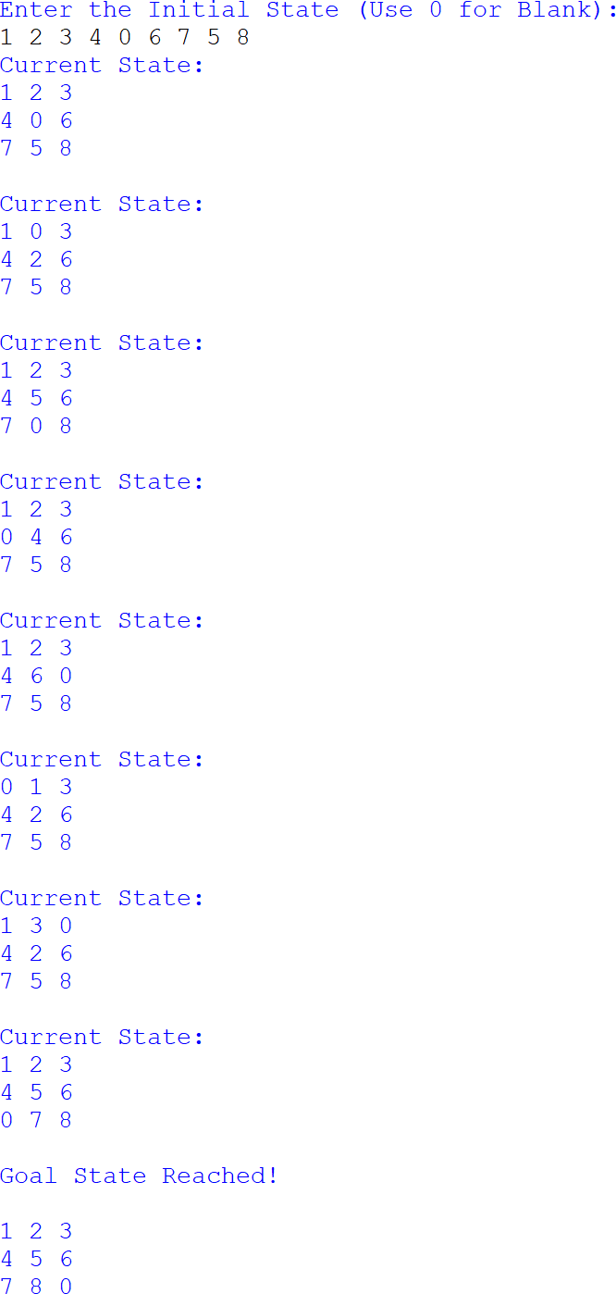

Experiment No: 2

8-Queen Problem

Program
N = 8

board = [[0 for _ in range(N)] for _ in range(N)]

def is_safe(row, col): # Check left side for i in range(col):
if board[row][i] == 1: return False

# Check upper diagonal i, j = row, col

while i >= 0 and j >= 0: if board[i][j] == 1:
return False
i -= 1
j -= 1

# Check lower diagonal i, j = row, col
while i < N and j >= 0: if board[i][j] == 1: return False
i += 1
j -= 1

return True

def solve(col): if col >= N:
return True

for row in range(N): if is_safe(row, col):
board[row][col] = 1

if solve(col + 1): return True

board[row][col] = 0

return False

if solve(0):
print("Solution Found:\n") for row in board:
print(*row)
else:
print("No Solution Exists")

Sample Input
No user input required.

Sample Output

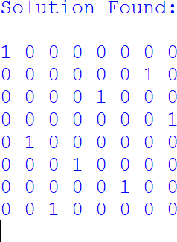

Experiment No: 3

Water Jug Problem

Program
from math import gcd

def water_jug(jug1, jug2, target): if target > max(jug1, jug2):
print("Target cannot be achieved.") return

if target % gcd(jug1, jug2) != 0: print("Target cannot be achieved.") return

x = 0
y = 0

print("\nSteps:")

while x != target and y != target:

if x == 0: x = jug1
print(f"Fill Jug1 -> ({x}, {y})")

elif y == jug2: y = 0
print(f"Empty Jug2 -> ({x}, {y})")

else:
transfer = min(x, jug2 - y) x -= transfer
y += transfer
print(f"Pour Jug1 -> Jug2 -> ({x}, {y})")

print("\nTarget achieved!")

jug1 = int(input("Enter capacity of Jug1: ")) jug2 = int(input("Enter capacity of Jug2: ")) target = int(input("Enter target quantity: "))

water_jug(jug1, jug2, target)

Sample Input
Enter capacity of Jug1: 4 Enter capacity of Jug2: 3 Enter target quantity: 2

Sample Output

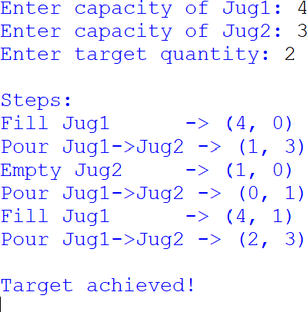

Experiment No: 4
Crypt-Arithmetic Problem Aim

Program
from itertools import permutations # Read input
word1 = input("Enter First Word: ").upper() word2 = input("Enter Second Word: ").upper() result = input("Enter Result Word: ").upper()

letters = list(set(word1 + word2 + result))

if len(letters) > 10:
print("Too many unique letters.") exit()
digits = '0123456789'

found = False

for perm in permutations(digits, len(letters)): table = dict(zip(letters, perm))

# Leading letter cannot be zero
if table[word1[0]] == '0' or table[word2[0]] == '0' or table[result[0]] == '0': continue

n1 = int(''.join(table[ch] for ch in word1)) n2 = int(''.join(table[ch] for ch in word2)) n3 = int(''.join(table[ch] for ch in result))

if n1 + n2 == n3: print("\nSolution Found\n") for k in sorted(table):
print(k, "=", table[k])

print("\n", n1)
print("+", n2) print(" ")
print(n3) found = True break

if not found:
print("No Solution Found.")

Sample Input
Enter First Word: SEND Enter Second Word: MORE Enter Result Word: MONEY

Sample Output

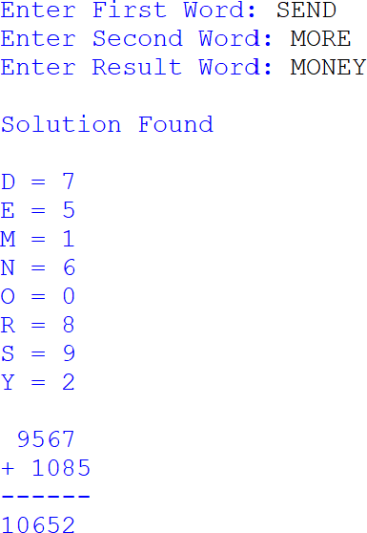

Experiment No: 5
Missionaries and Cannibals Problem

Program
from collections import deque

# Check whether the state is valid def is_valid(m_left, c_left):
m_right = 3 - m_left c_right = 3 - c_left

if m_left < 0 or c_left < 0 or m_left > 3 or c_left > 3: return False
if (m_left > 0 and c_left > m_left):

return False

if (m_right > 0 and c_right > m_right): return False

return True

# BFS Algorithm
def missionaries_cannibals(): start = (3, 3, 'L')
goal = (0, 0, 'R')

moves = [(1,0), (2,0), (0,1), (0,2), (1,1)]

queue = deque([[start]]) visited = set()

while queue:
path = queue.popleft() state = path[-1]

if state == goal: print("Solution Path:\n") for s in path:
print(s) return

if state in visited: continue

visited.add(state)

m, c, boat = state

for dm, dc in moves:

if boat == 'L':
new_state = (m-dm, c-dc, 'R') else:
new_state = (m+dm, c+dc, 'L')

if is_valid(new_state[0], new_state[1]): queue.append(path + [new_state])

print("No Solution Found") missionaries_cannibals()

Sample Input
No user input required.

Sample Output
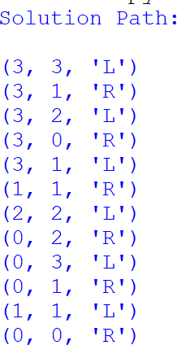

Experiment No: 6

VacuumCleanerProblem

Program
# Vacuum Cleaner Problem using DFS

rooms = {}

n = int(input("Enter the number of rooms: "))

for i in range(n):
room = input(f"Enter Room Name {i+1}: ")
status = input(f"Enter Status of {room} (Dirty/Clean): ").capitalize()

rooms[room] = status

print("\nInitial Room Status") print(rooms)

visited = set()

def dfs(room):
if room in visited: return

visited.add(room)

if rooms[room] == "Dirty": print(f"{room} is Dirty -> Cleaning...") rooms[room] = "Clean"
else:
print(f"{room} is already Clean.")

print("\nCleaning Process")

for room in rooms:
if room not in visited: dfs(room)

print("\nFinal Room Status") print(rooms)

Sample Input
Enter the number of rooms: 2 Enter Room Name 1: A
Enter Status of A (Dirty/Clean): Dirty Enter Room Name 2: B
Enter Status of B (Dirty/Clean): Dirty

Sample Output
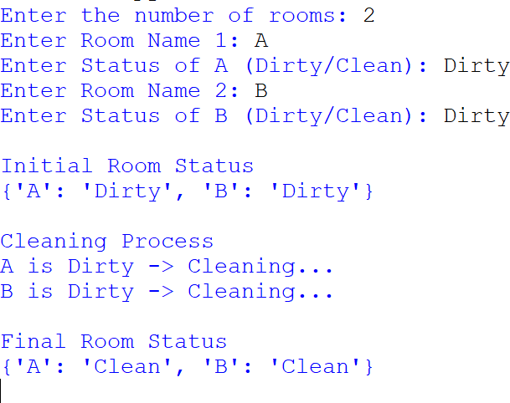
Experiment No: 7

Breadth First Search (BFS)

Program
from collections import deque

# Breadth First Search Function def bfs(graph, start, goal):

queue = deque([(start, [start])]) visited = set()

while queue:

node, path = queue.popleft()

if node == goal: return path

if node in visited: continue

visited.add(node)

for neighbour in graph[node]: if neighbour not in visited:
queue.append((neighbour, path + [neighbour]))

return None

# Main Program

graph = { 0: [1, 2],
1: [0, 2, 3],
2: [0, 1, 3],
3: [1, 2, 4],

4: [3]
}

print("Graph Representation") print(" ")

for node in graph:
print(node, "->", graph[node])

print()

start = int(input("Enter Source Node : ")) goal = int(input("Enter Destination Node : "))

path = bfs(graph, start, goal)

print()

if path:

print("Breadth First Search Successful") print(" ")
print("Source Node :", start) print("Destination Node :", goal)
print("Shortest Path :", " -> ".join(map(str, path))) print("Number of Nodes Visited :", len(path))

else:
print("No Path Found")

Sample Input
Enter Source Node 0
Enter Destination Node : 4

Sample Output
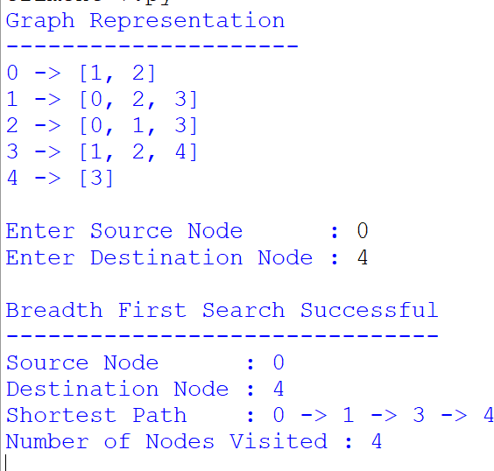
Experiment No: 8

Depth First Search (DFS)

Program
# Depth First Search (DFS)

graph = {
'A': ['B', 'C'],
'B': ['D', 'E'],
'C': ['F'],
'D': [],

'E': ['F'], 'F': []
}

visited = set()

def dfs(node):

if node not in visited:

print(node, end=" ")

visited.add(node)

for neighbour in graph[node]: dfs(neighbour)

print("Graph:") for node in graph:
print(node, "->", graph[node])

print("\n\nDFS Traversal:")

dfs('A')

Sample Input
Starting Node : A
(The graph is predefined in the program.)

Sample Output
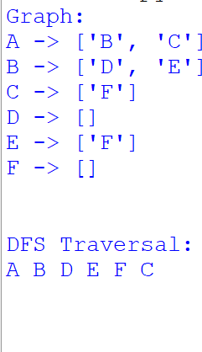

Experiment No: 9

Travelling Salesman Problem (TSP)

Program
import numpy as np

def tsp(cities):

n = len(cities)

# Create Distance Matrix distance = np.zeros((n, n))

for i in range(n): for j in range(n):
if i != j:
distance[i][j] = np.linalg.norm(cities[i] - cities[j])

visited = [False] * n visited[0] = True

tour = [0]
total_distance = 0
current = 0

while len(tour) < n:

nearest = -1
minimum = float('inf')

for city in range(n):

if not visited[city] and distance[current][city] < minimum: minimum = distance[current][city]
nearest = city

tour.append(nearest)

visited[nearest] = True total_distance += minimum current = nearest

total_distance += distance[current][0] tour.append(0)

return tour, total_distance

# Main Program

n = int(input("Enter Number of Cities: "))

cities = []

for i in range(n):
x = float(input(f"Enter x-coordinate of City {i}: ")) y = float(input(f"Enter y-coordinate of City {i}: ")) cities.append(np.array([x, y]))

tour, distance = tsp(cities)

print("\nOptimal Tour")
print(" -> ".join(map(str, tour)))

print("Total Distance =", round(distance,2))

Sample Input
Enter Number of Cities: 4

City 0 : (0,0)

City 1 : (2,3)

City 2 : (5,2)

City 3 : (6,6)

Sample Output

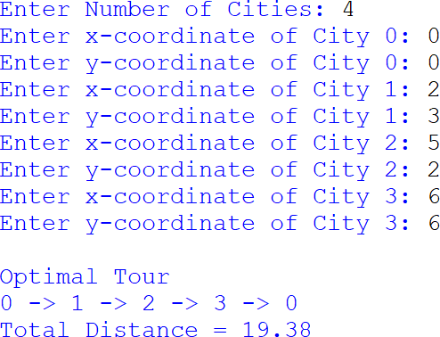

EXPERIMENT 10:
A* algorithm.

Program:
import heapq

def a_star(graph, heuristic, start, goal):
queue = [(heuristic[start], 0, start, [start])]
visited = set()

while queue:
f, cost, node, path = heapq.heappop(queue)

if node == goal:
return path, cost

if node in visited:
continue

visited.add(node)

for neighbour, distance in graph[node]:
if neighbour not in visited:
new_cost = cost + distance
f_value = new_cost + heuristic[neighbour]

heapq.heappush(
queue,
(f_value, new_cost, neighbour,
path + [neighbour])
)

return None, None

# Graph with edge costs
graph = {
'A': [('B', 1), ('C', 4)],
'B': [('D', 2), ('E', 5)],
'C': [('E', 1)],
'D': [('F', 3)],
'E': [('F', 2)],
'F': []
}

# Heuristic values
heuristic = {
'A': 5,
'B': 4,
'C': 3,
'D': 3,
'E': 2,
'F': 0
}

start = 'A'
goal = 'F'

path, cost = a_star(graph, heuristic, start, goal)

if path:
print("Shortest Path:", " -> ".join(path))
print("Total Cost:", cost)
else:
print("Path not found")

Sample Output:

Shortest Path: A -> B -> D -> F
Total Cost: 6

Experiment 11:

Map Coloring Using CSP:

Program:
# Map Coloring using CSP

regions = ['A', 'B', 'C', 'D']

# Adjacent regions
neighbors = {
'A': ['B', 'C'],
'B': ['A', 'C', 'D'],
'C': ['A', 'B', 'D'],
'D': ['B', 'C']
}

# Available colors
colors = ['Red', 'Green', 'Blue']

assignment = {}

def is_safe(region, color):
for neighbor in neighbors[region]:
if neighbor in assignment:
if assignment[neighbor] == color:
return False
return True

def map_coloring(index):
# All regions are colored
if index == len(regions):
return True

region = regions[index]

for color in colors:
if is_safe(region, color):
assignment[region] = color

if map_coloring(index + 1):
return True

# Backtracking
del assignment[region]

return False

# Solve CSP
if map_coloring(0):
print("Map Coloring Solution:")

for region in regions:
print("Region", region, ":", assignment[region])

else:
print("No solution found")

Sample Output:

Map Coloring Solution:
Region A : Red
Region B : Green
Region C : Blue
Region D : Red
Experiment 12:

Tic Tac Toe game

# Tic-Tac-Toe Game

board = [' ' for i in range(9)]

def display_board():
print()
print(board[0], "|", board[1], "|", board[2])
print("--+---+--")
print(board[3], "|", board[4], "|", board[5])
print("--+---+--")
print(board[6], "|", board[7], "|", board[8])
print()

def check_winner(player):
winning_positions = [
(0, 1, 2),
(3, 4, 5),
(6, 7, 8),
(0, 3, 6),
(1, 4, 7),
(2, 5, 8),
(0, 4, 8),
(2, 4, 6)
]

for a, b, c in winning_positions:
if board[a] == board[b] == board[c] == player:
return True

return False

def play_game():
player = 'X'

for turn in range(9):
display_board()

print("Player", player)

try:
position = int(input("Enter position (1-9): ")) - 1
except ValueError:
print("Please enter a number from 1 to 9.")
continue

if position < 0 or position > 8:
print("Invalid position!")
continue

if board[position] != ' ':
print("Position already occupied!")
continue

board[position] = player

if check_winner(player):
display_board()
print("Player", player, "wins!")
return

if player == 'X':
player = 'O'
else:
player = 'X'

display_board()
print("Game Draw!")

play_game()

Sample Output:

| |
--+---+--
| |
--+---+--
| |

Player X
Enter position (1-9): 1

X | |
--+---+--
| |
--+---+--
| |

Player O
Enter position (1-9): 5

